Al-Driven Exploration and Prediction of Company Registration Trends with Registrar of Companies (ROC)

Here are some ideas to build an AI-driven exploration and prediction system for company registration trends with Registrar of Companies (ROC):

1. **Data collection**: The first step is to collect data on company registrations from ROC. This data can include information such as company name, registration date, type of company, location, industry, and other relevant details.

2. **Data cleaning and preparation**: The collected data needs to be cleaned and prepared for analysis. This involves removing duplicates, missing values, and inconsistencies in the data.

3. **Exploratory data analysis**: Once the data is cleaned and prepared, exploratory data analysis can be performed to identify patterns and trends in the data. This can involve visualizations, statistical analysis, and clustering techniques.

4. **Machine learning models**: Machine learning models can be developed to predict future company registration trends based on historical data. These models can be trained using various algorithms such as regression, decision trees, random forests, and neural networks.

5**. Natural language processing (NLP)**: NLP techniques can be used to analyze unstructured data such as news articles and social media posts to identify trends and sentiment related to company registrations.

6**. Interactive dashboard**: An interactive dashboard can be built to visualize the results of the analysis and provide insights to users. This dashboard can include features such as filters, drill-downs, and real-time updates.

7. **Integration with other systems**: The AI-driven system can be integrated with other systems such as customer relationship management (CRM) and enterprise resource planning (ERP) systems to provide a comprehensive view of company registration trends.

Overall, an AI-driven exploration and prediction system for company registration trends with ROC can provide valuable insights to businesses, investors, and policymakers.

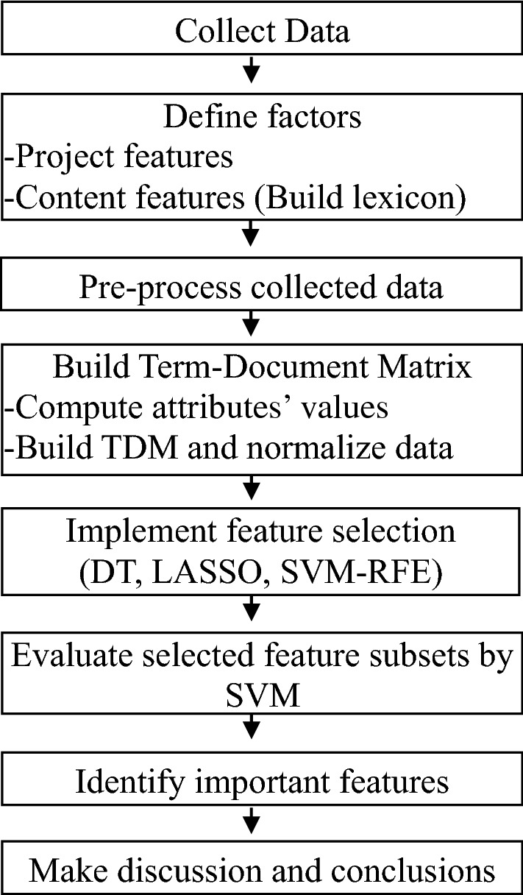

Here are some ideas for preprocessing the dataset:

1. **Remove duplicates**: Check the dataset for any duplicate entries and remove them.

2**. Handle missing values**: Check if there are any missing values in the dataset and handle them appropriately. This can be done by either removing the rows with missing values or imputing them using techniques such as mean, median, or mode.

3. **Standardize data**: If the dataset contains numerical data, it is recommended to standardize the data to have a mean of 0 and a standard deviation of 1. This can help improve the performance of machine learning models.

4**. Encode categorical variables**: If the dataset contains categorical variables, they need to be encoded to numerical values before feeding them into machine learning models. This can be done using techniques such as one-hot encoding or label encoding.

5**. Feature scaling**: If the dataset contains numerical data with different scales, feature scaling can be applied to normalize the data. This can be done using techniques such as min-max scaling or z-score normalization.

6. **Outlier detection**: Check for any outliers in the dataset and handle them appropriately. This can be done by either removing the outliers or treating them as a separate category.

7**. Data sampling**: If the dataset is imbalanced, data sampling techniques such as oversampling or undersampling can be applied to balance the classes.

By preprocessing the dataset, we can ensure that the data is clean and ready for analysis. This can help improve the accuracy and reliability of the AI-driven exploration and prediction system for company registration trends with ROC.

